Shaik Sharifa Jahan

AP22110011103

1. Write an assembly language program to perform division of 8-bit data.

org 100h

mov al,96h

mov bl,21h

idiv bl

mov bl,al

mov bh,ah

and al,0f0h

shr al,4

add al,30h

cmp al,39h

jle print_first_digit1

add al,7

print_first_digit1:

mov dl,al

mov ah,02h

int 21h

mov al,bl

and al,0fh

add al,30h

cmp al,39h

jle print_second_digit1

add al,7

print_second_digit1:

mov dl,al

mov ah,02

int 21h

mov al,bh

and al,0f0h

shr al,4

add al,30h

cmp al,39h

jle print_first_rem_digit

add al,7

print_first_rem_digit:

mov dl,al

mov ah,02h

int 21h

mov al,bh

and al,0fh

add al,30h

cmp al,39h

jle print_second_rem_digit

add al,7

print_second_rem_digit:

mov dl,al

mov ah,02h

int 21h

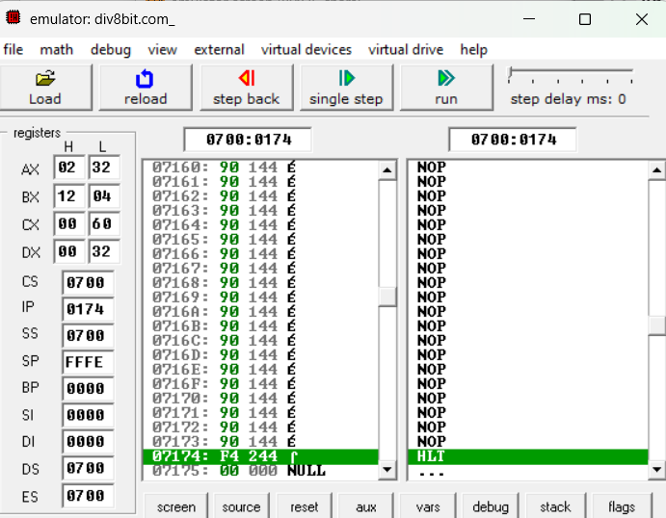

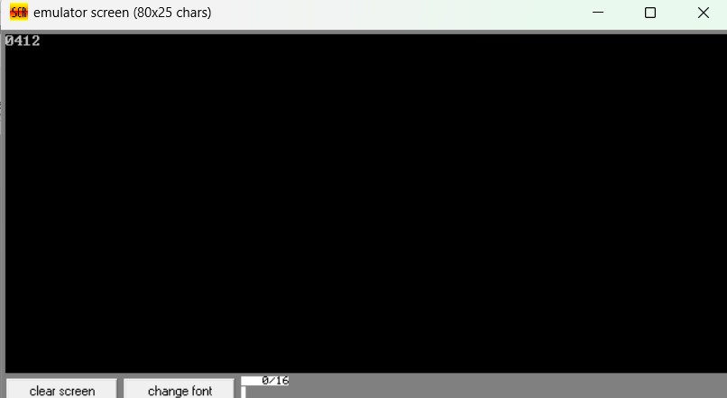

1. Write a program in assembly language to perform division of 16-bit data.

org 100h

mov ax,1780h

mov bx,1000h

div bx

mov bx,ax

mov cx,dx

mov ah,ch

and ah,0f0h

shr ah,4

add ah,30h

cmp ah,39h

jle print_high_nibble32

add ah,7

print_high_nibble32:

mov dl,ah

mov ah,02h

int 21h

mov ah,ch

and ah,0fh

add ah,30h

cmp ah,39h

jle print_low_nibble32

add ah,7

print_low_nibble32:

mov dl,ah

mov ah,02h

int 21h

mov ah,cl

and ah,0f0h

shr ah,4

add ah,30h

cmp ah,39h

jle print_low_nibble24

add ah,7

print_low_nibble24:

mov dl,ah

mov ah,02h

int 21h

mov ah,cl

and ah,0fh

add ah,30h

cmp ah,39h

jle print_high_nibble24:

add ah,7

print_high_nibble24:

mov dl,ah

mov ah,02h

int 21h

mov ah, bh

shr ah, 4

add ah, 30h

cmp ah, 39h

jle print_high_nibble

add ah, 7

print_high_nibble:

mov dl, ah

mov ah, 02h

int 21h

mov ah, bh

and ah, 0fh

add ah, 30h

cmp ah, 39h

jle print_low_nibble

add ah, 7

print_low_nibble:

mov dl, ah

mov ah, 02h

int 21h

mov ah, bl

shr ah, 4

add ah, 30h

cmp ah, 39h

jle print_high_nibble2

add ah, 7

print_high_nibble2:

mov dl, ah

mov ah, 02h

int 21h

mov ah, bl

and ah, 0fh

add ah, 30h

cmp ah, 39h

jle print_low_nibble2

add ah, 7

print_low_nibble2:

mov dl, ah

mov ah, 02h

int 21h

mov ah,4ch

int 21h

